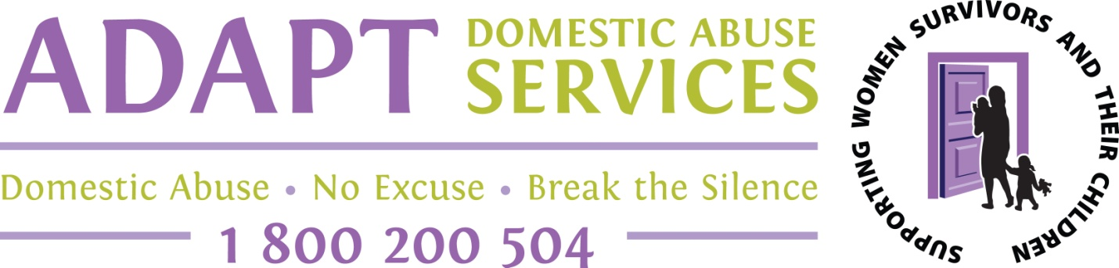

APPLICATION FOR TRAINING

1 Day Course ‘UNDERSTANDING DOMESTIC ABUSE’

Dates for 2017 to be announced

Course Fee €30 (Students €10)

Please tick payment method

Cash ___ or

Invoice to Employer ___ (please give Employer’s name, address, ref no etc. below)

________________________________________________________________________

Your Name ______________________________________________________________

Email _______________________________________________________________

Phone _______________________________________________________________

Occupation __________________________________________________________

Please send application form to Deirdre Barrett, at development@adaptservices.ie
Or post to Training & Development, ADAPT House, Rosbrien, Limerick.

